3D TEXT ON FIRE

STEP 1
Open up Illustrator and type out a word of your choice, in my case I used the word â€œFIREâ€ in ITC Franklin Gothic Heavy. Make sure that each letter is in a different text box. Now using Effect>3D>Extrude & Bevel set up your letters in an interesting way, keeping in mind that they are going to be on fire. It doesnâ€™t have to be exactly the same, but something like what I have below. If you are having trouble with the 3D text, you can look at the tutorial on creating 3D text.
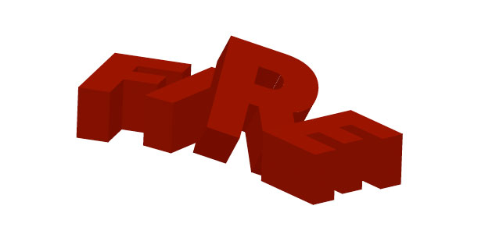

STEP 2
Open up Photoshop, and create a new document (Iâ€™m using 1680×1050). Fill the background with black. Paste the text you created in Illustrator. Make sure you bring in one letter at a time so they are all on different layers. Resize the text and adjust the angle until you get something that you are happy with.
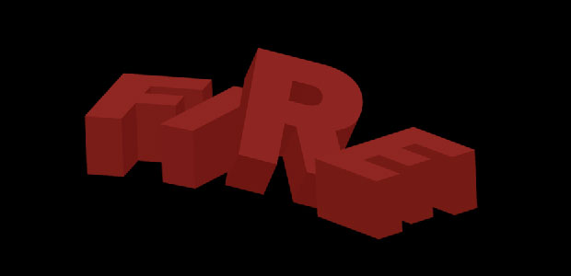

STEP 3
We are going to work on the background first, so grab a yellow/orangish color (Something that kind of has a fire look to it) and create a circular gradient with our color fading to 0% opacity. Stretch the gradient out with your transform tool until youâ€™ve created somewhat of a glow under your text.
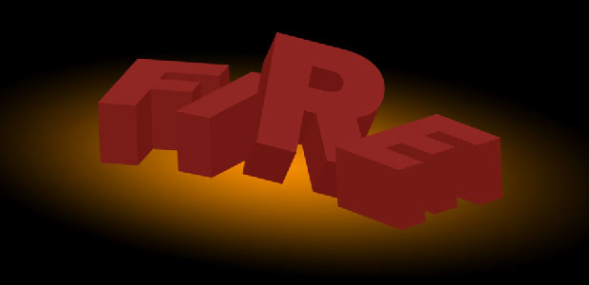

STEP 4
Grab the ground texture that we downloaded and bring it into our document. Decrease the size and adjust the angle so it looks like it is under the text. If you hold down the apple key and drag one of the corners it distorts it, so you can get a better perspective. Drag it so it is above the gradient layer and change the blend mode to multiply. You can adjust the size of the gradient so there is more ground showing.
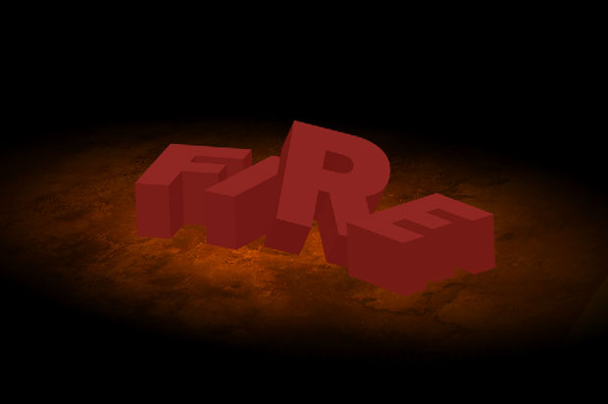

STEP 5
Now we can start adding in the fire. You can use the lasso tool to roughly cut out the parts of the fire you want.
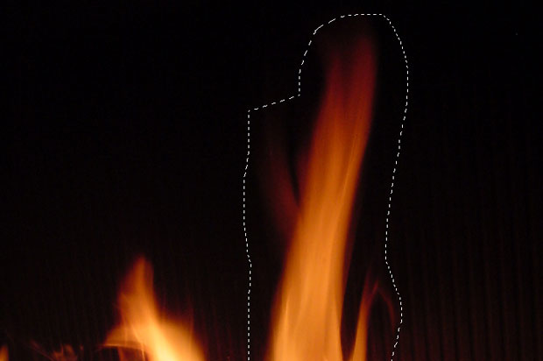

STEP 6
Bring your cut out fire pieces into the document and place them in and around the text. Change the blend mode to lighten on your fire, this will get rid of most of the black areas around the fire. Play around with the flames until you get something you like.
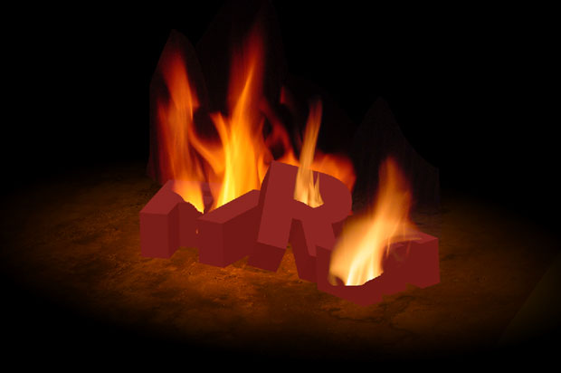

STEP 7
Now we want to get rid of the sharp edges we have from cutting out the fire from the other images. So what we want to do is click on each layer, apply a layer mask and then use a black brush with a soft edge to start painting out the edge of our fire.
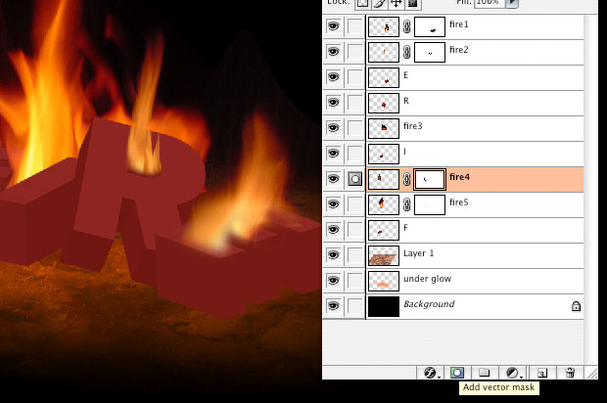

STEP 8
Lets give our text a shadow that is cast by the fire, so it will be a fairly high contrast one. Load each layer of our FIRE text and fill a new layer with black, with our selected area. Go into filter>blur>radial blur, put the amount up to 100 and set the blur method to zoom. Repeat that filter with apple + f, then duplicate that layer. Then merge the two layers.
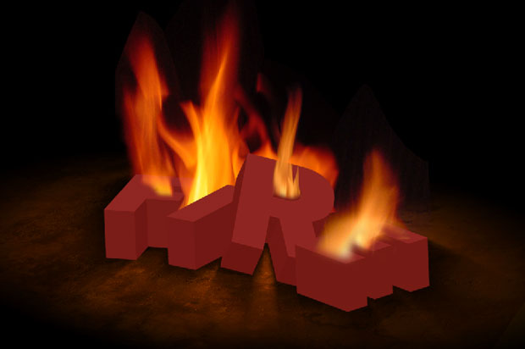

STEP 9
Now like we did with the fire, we are going to mask out the spots that isnâ€™t supposed to have a shadow. Like all around the back we want to get rid of, as well as spots where light would come through the letters.
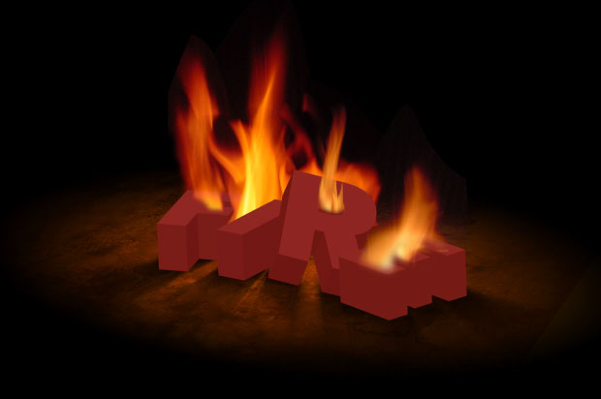

STEP 10
Now comes the time consuming part. I usually make a folder for each letter, then at least two different layers for each letterâ€™s shadow and usually one for the highlight. So lets start off with the E. Create a new folder for it in your layers. Then create a layer for our shadow. Use the tool of your choice to get the selections, Iâ€™m going to use the polygonal lasso tool (and the pen tool for the curved letters). Now Grab a big black brush and drop the opacity down to 20%. I usually use one that covers most of the shape Iâ€™m trying to paint to get an even shadow. Now start painting, one click at a time, making the bottom darker than the top.
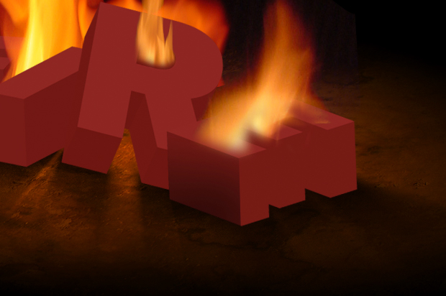

STEP 11
Grab another part of the E, one that doesnâ€™t touch the area we already darkened and continue shadowing. You can hide the fire layers, it will make the letters easier to see. So just repeat this with all your shadow layers. Creating a new folder for each letter, and a new layer for the opposite dark areas. This is one of those things that the more you do it the more you get better, and it takes practice to get good at it.
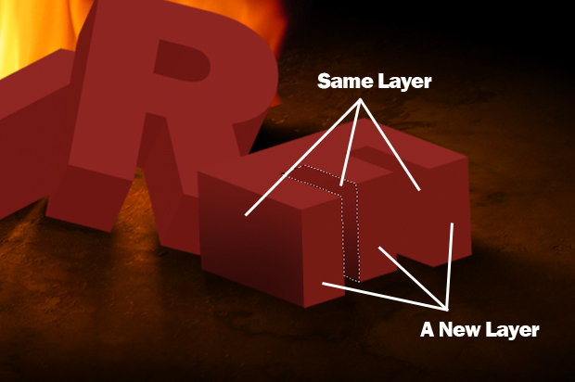

STEP 12
Now we are going to start working on the highlights. Using the lasso tool (and the pen tool for the curved areas), cut out one top at a time then putting them in the corresponding folders. Set your highlight layers to overlay and use a combination of yellow, orange and white colors to give the tops of the letters a highlight effect. Repeat this for each letter until you get something you like. If you want to add more intensity to the glow, duplicate the layer or create a new layer and start painting on that.
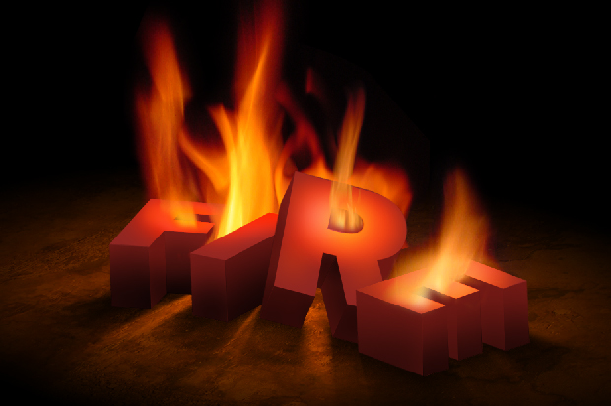

STEP 13
Now we want to grab the texture that what got in the beginning. This is going to give our text a burnt look. So bring the texture into the document and size it until you find a good look for the E. Then load the E layer and select the inverse selection using apple + shift + i and delete. Since it is a lighter texture, I am gong to do an inverse, to make it darker (apple + I). Then Change the blend mode to multiply.
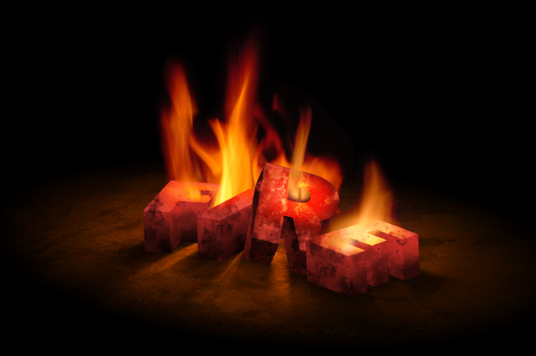

FINAL
This is my process when it comes to creating scenes with 3D lettering. This tutorial was created to give you an idea of how to create something like this with some basic steps and a little time.

